Instructions for Making 9-Generation GBIP Chart with Pictures

Hardware needed:
Computer
Inkjet printer
Scanner -- for pictures

Software needed:
Microsoft Office “Word”
Graphics program - for editing and cropping pictures (We used Adobe Elements.)

Other items needed:
Nine-Generation Pedigree Chart from GENEALOGICAL BOOKS IN PRINT
Web page: www.gbip.biz for additional copies
Avery Clear Full Sheet Labels #8665 (available at most office supply stores)
White-out for obliterating lines where pictures will be used for numbers 16 - 31.

Fonts used for chart
For names: Lucida Sans, bold - Point size # 11
For dates and places: Goudy Old Style , regular - Point size #11
[Your printer will choose closest match if it does not support these fonts.]
______________________________________________________

Step # 1 - Accumulate materials
- Make chart similar to the one you bought from GBIP on large sheet of paper (or) purchase folded worksheet from GBIP [www.gbip.biz] . Number each person whose name you will be recording on the chart so you know where data are to be placed. The paternal line will be on top half of chart; the maternal line will be on bottom half. To ascertain that each line is placed correctly, note that a father’s number will be doubled with each generation, thus the surname paternal line will be numbers 2, 4, 8, 16, 32, 64, 128, 256. A wife’s number is her husband’s number plus one; but then each of the wife’s male ancestor’s numbers will also be doubled; thus #5’s paternal line will be 10, 20, 40, 80, etc. Number 5’s mother will be #11; her mother’s male line will be 22, 44, 88, etc.

- Check your files for names, dates and places and record on your work sheet chart.

Step # 2 - Load the template.
- After loading, immediately save the file as “Pedigree chart for [your name]” and work from that file so--should you erase something accidentally--you will still have the original to go back to.

Step # 3 - Fill in template
- Hi-light the first line “Your name. #1. Start typing in your name and it will replace “Your name #1” on the template with your actual name. Your actual name will appear in the proper font and font size for the chart.

- Hi-light the “Date of birth” and type your date of birth. It will be in the correct font and font size and spaced to fit lines. Do same with “Place of birth”, “Date of Marriage”, etc. Continue for entire chart.

Step # 4 - Scan pictures.
- Edit pictures. Size each to 1” wide by 1 ¼“ high. Copy them to template provided for
36 (or less) pictures.

Step # 5- Print text and pictures on the label paper
- It is a good idea to make a trial run by printing out the text on regular paper on the same printer you will be using to print the label paper. This may prevent wasting a sheet of expensive label paper. Your printer may give an error message which says “The margins of the printer are set outside the page margins. Do you want to continue?” Say “Yes”, but double check printed page to make sure everything did get printed before proceeding--the margin varies from printer to printer; also a column may have slipped. Print label and examine carefully to make sure all text is in proper place. When you have ascertained that all text is as planned, place the label paper in the in-tray. Print one page at a time and check each to make sure all is printed on the label sheet before proceeding to next page. [If the bottom line didn’t print, you can manually add that line to one of the later pages rather than wasting a sheet of label paper by printing it over again. (See page 5 of template.)

- Print pictures on label paper

Step #6 - Affix label paper to pedigree chart
- Cut first sheet of the label paper into its three columns making sure all components that belong to each column are in the strip, i.e. name, dates, places.
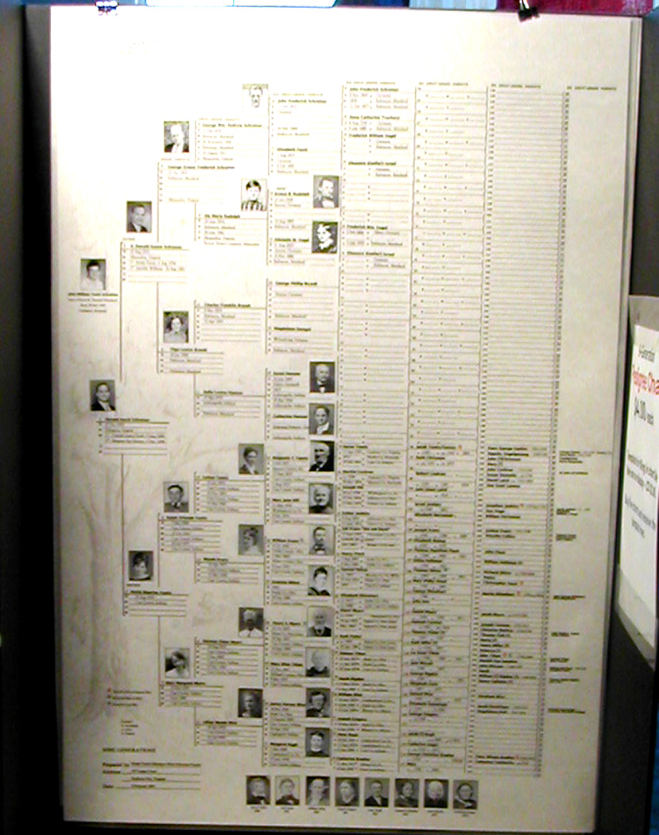

- Match up the numbers on your label paper with the numbers on chart. Check to make sure you are placing the name in the correct spot by referring to your worksheet chart.

- Information on each of the individuals from #1 through #15 will need to be cut apart and placed on chart separately. Place text about  inch be-tween printing on chart and text on label paper. Check to see if the names, dates and places are about equal distance from the lines beneath them. Press lightly into place. (You can take up and reposition the text. This is easier if done im-mediately as it adheres more firmly with time.)

- From #16 to #127 (perhaps to #255) text will be put down in strips approximately 9” long.

- From #128 (or #256) to #511, you will probably have large gaps in the names on your chart.. You will need to determine what ancestors you have information about and type these onto the template. When you have several ancestors in a row, or with only one or two missing, you can put them down in strips, others will have to be affixed individually. You probably need to cut the template and omit sections where no names appear.

- After placing all the text on the chart and making sure you have each person in the correct spot, take up the page of pictures. Leaving a small margin around each side, cut each picture out carefully with scissors or a razor blade; remove backing from each just before you affix it next to the person’s name.

- There will be plenty of room for pictures in the first four generations, i.e. #1 through #15. Place picture by centering in available space, or by leaving consistent margin.

- In the 5th generation (#16 through #31) you will need to white-out the lines which will fall under the pictures or the lines will show through the transparent pictures. [We found BIC Wite-Out “Extra Coverage” Correction Fluid provided the best coverage and dried quckly.]
- You will also need to make sure the names, dates, etc. do not intrude on the pictures. This is easy to do. Just lay the pictures down (without removing the backing) and see if names, or dates, or places extend under the picture. If they do, abbreviate states instead of spelling them out, and use middle initials instead of full names.

- Use REMOVABLE Scotch tape (has blue core) to help white-out the lines where the picture will be. This will keep the chart tidy by making the lines end precisely at the border of the pictures. Place the tape so the right-hand side will be 1 inch from the lines on the right--those along left side of numbers 32 to 63. Since your pictures will be 1” wide, this will allow an ” between the picture and the right-hand line. Place pictures temporarily where they will eventually be affixed to the chart. Do not remove backing until you have used the white-out and it has dried. With a pencil, mark each line that will have to be whited-out. [For the men, this will be two lines--the line his name is on and the line his birth date is on. For the women, it will be four lines--the lines showing her husband’s date of death and place of death and her own name line and that of her date of birth.] White-out using one or more pieces of removable tape. Place the tape into place firmly so the white-out will not flow under it. Unless you have a picture for every number from #16 through #31, you need to make sure you indicate to yourself exactly which numbers have pictures and which DO NOT. You don’t want to white-out lines of those that will NOT have pictures. It may be a good idea to put a piece of the removable tape across those that will NOT have pictures and mark them with an “X” just to make doubly sure you don’t goof up. (Voice of experience!)

- Carefully white-out the appropriate lines, let the white-out dry, then remove the removable tape. At this point, you may take off the backing from pictures and affix them permanently to the chart.

- Left over pictures. There is not room after the 5th generation to place pictures next to each ancestor’s name. Instead, place pictures belonging to the paternal line at the top of the page and those belonging to the maternal line at the bottom of the page. Designate the name and number of the ancestor on the chart by placing a caption under the picture revealing the person’s name and #. If you have only a few “leftover” pictures, you may prefer to place them all at the top or all at the bottom.

- Adding additional information. You may want to place stars next to the names of persons who served in the various wars. Perhaps you have many ministers on your family tree and want to indicate those, or you may want to use symbols to illustrate information such as inheritable traits. If you include such items, be sure to place a key to the symbols you used at the bottom left of the chart.

- Lastly, fill in your name (or that of the person(s) responsible for its creation) as preparer of the chart. Record current address of preparer(s), and the date of preparation.

- Have fun! If you absolutely can’t do your chart without further instructions, my e-mail is:
nsy@GBIP.biz . Netti P.S. I cannot help you with graphics!

